**TEAM 3**

**Employee Payslip Management System**

# Objective:

To develop an interactive mainframe-based Employee Payslip Management System using COBOL, CICS, VSAM, and JCL on the Mocha TN3270 terminal emulator. The system allows managing employee data and automating monthly payslip generation.

# 2. Functional Requirements:

## 2.1 Employee Registration / Update Module

- Register new employees or update existing records.  
- Employee ID in format 'E0001'.  
- User inputs: Name, Gender, Date of Joining.  
- If Employee ID is entered, display existing data.

Employee KSDS

|  |  |  |
| --- | --- | --- |
| Field Name | size | Description |
| EMPLOYEE_ID | 5 | Key. Format: (e.g., E0001) |
| EMPLOYEE_NAME | 20 | Employee name |
| EMPLOYEE_AGE | 3 | Employee age |
| EMPLOYEE_GENDER | 6 | Gender: Male or Female |
| DATE_OF_JOINING | 10 | Date the employee joined |

## 2.2 Payslip Generation Module

- Generate payslips for employees.  
- Payslip ID in format 'P0101'.

- If emp-id is E0001, 2nd and 3rd positions in payslip id is last two characters of emp-id. And 3rd and 4th position are taken as a month for January its 01.

Payslip KSDS File

|  |  |  |
| --- | --- | --- |
| Field Name | size | Data Type |
| PAYSLIP_ID | 5 | Key. Format: (e.g., P0001) |
| PAYSLIP_DATE | 10 | Always 1st of the month (e.g., 2025-05-01) |
| NEXT PAYSLIP_DATE | 10 | Date of next payslip |
| NO_OF_WORKING_DAYS | 2 | Days between last and current payslip |
| NO.OF DAYS PRESENT | 2 | Number days presented |

3.Programming

Mapset 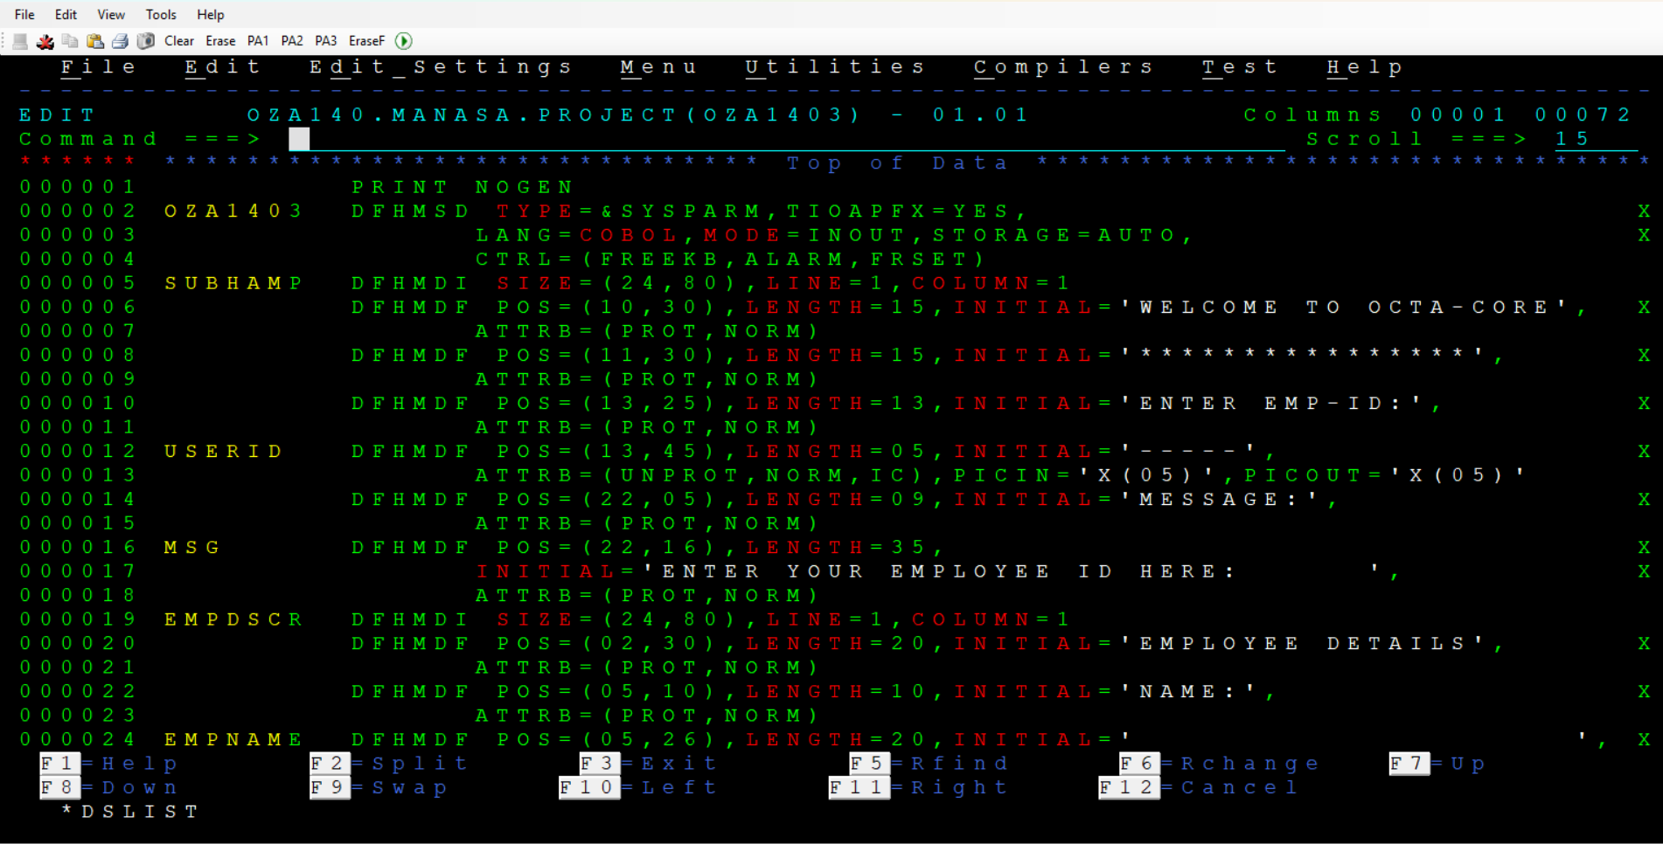

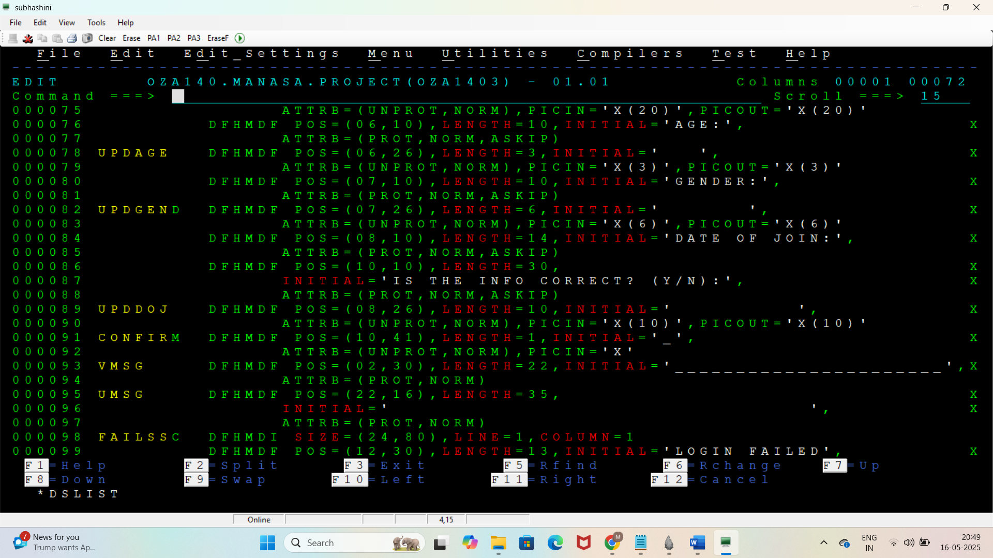

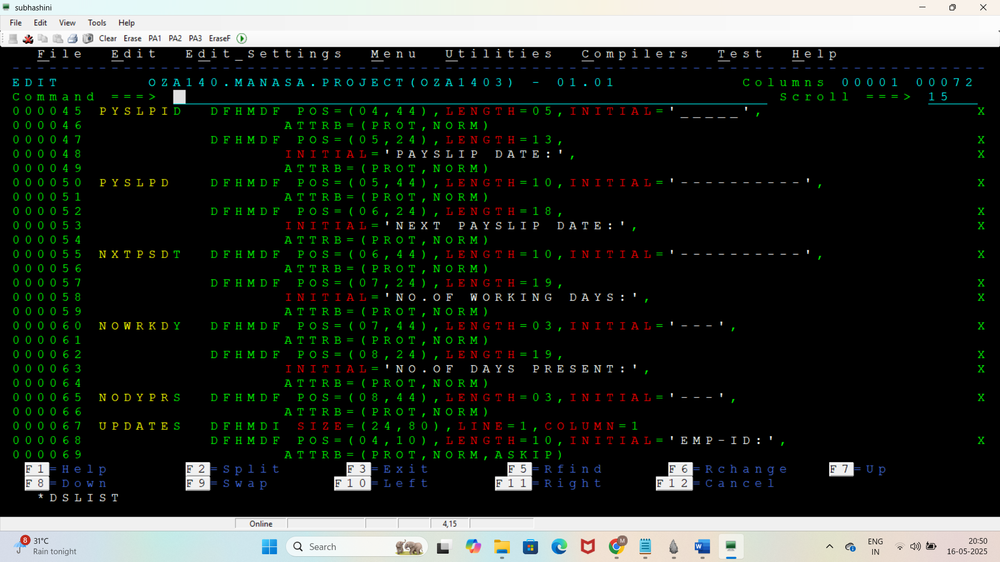

Jcl for mapset

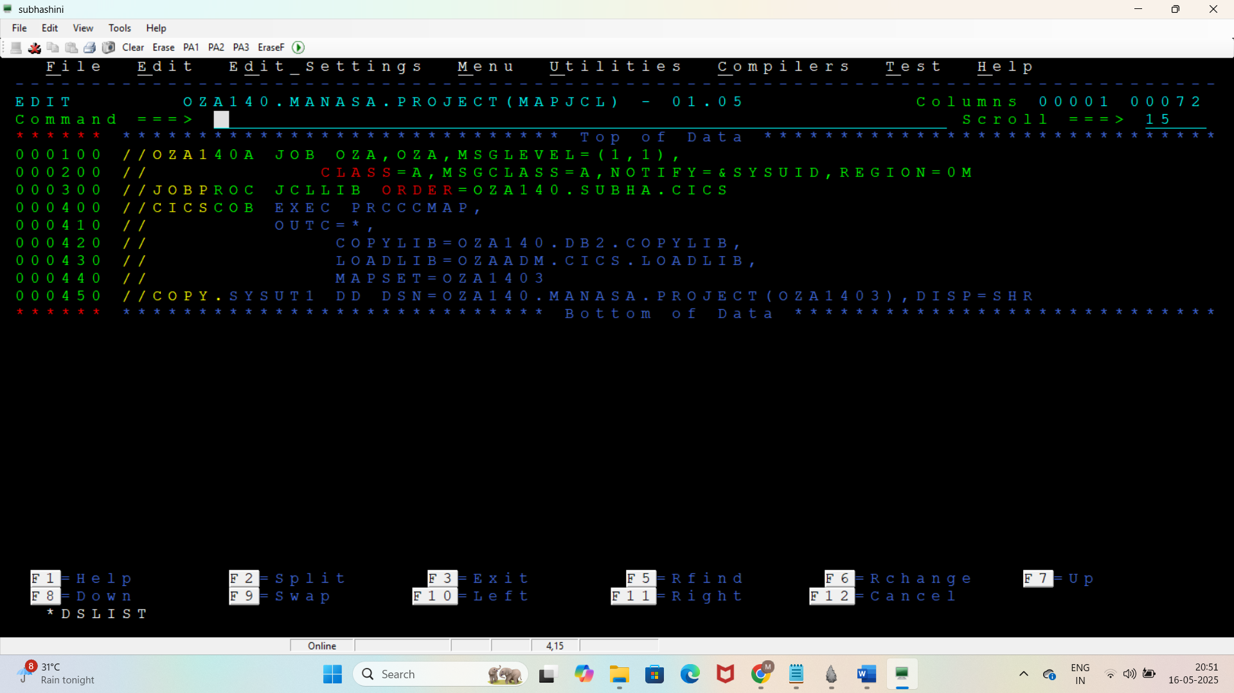

Main program

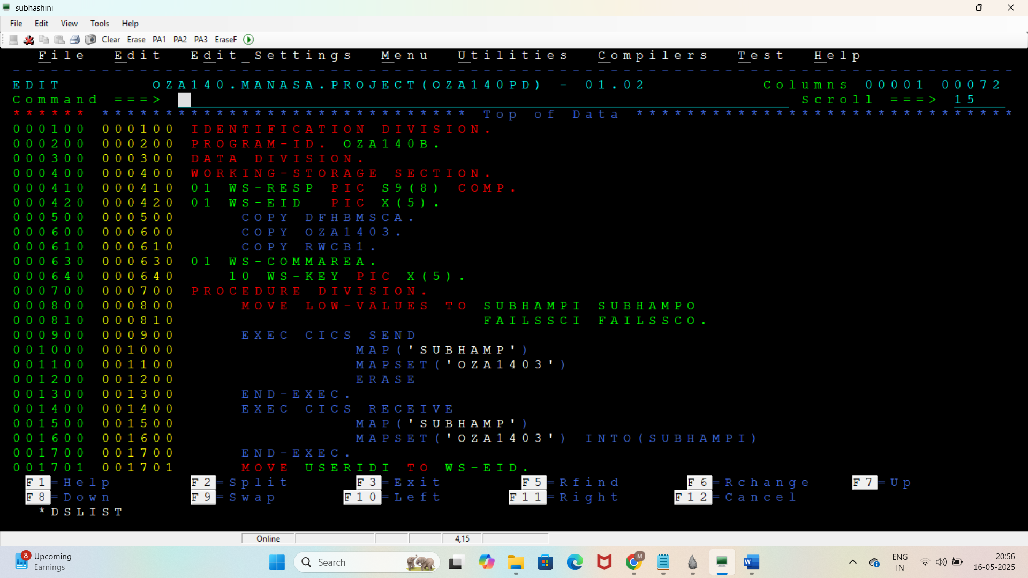

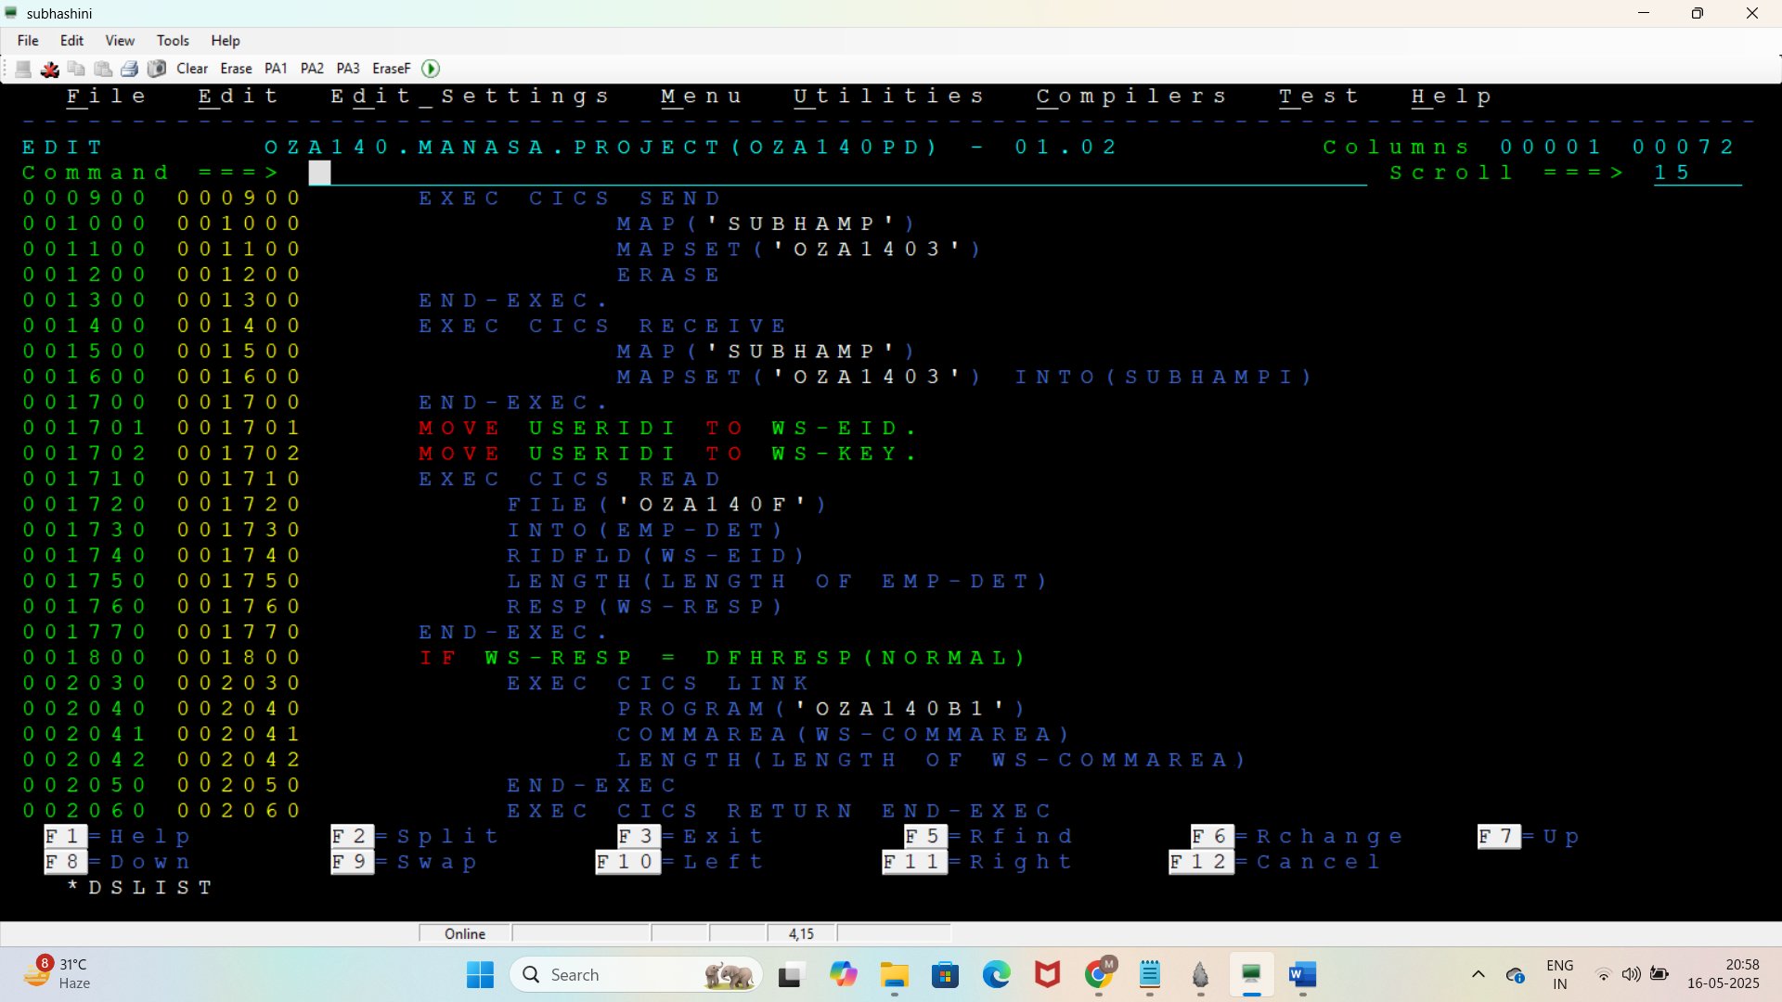

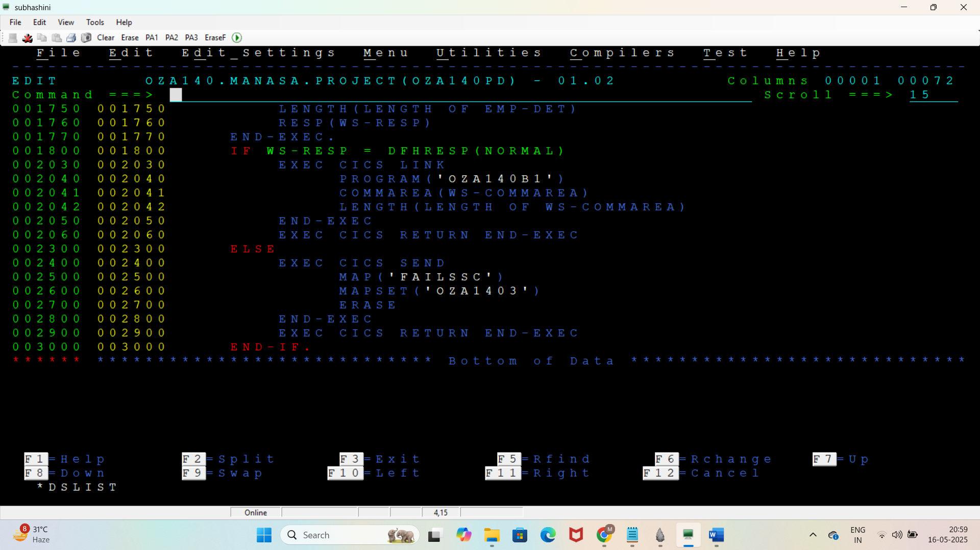

Subprogram1

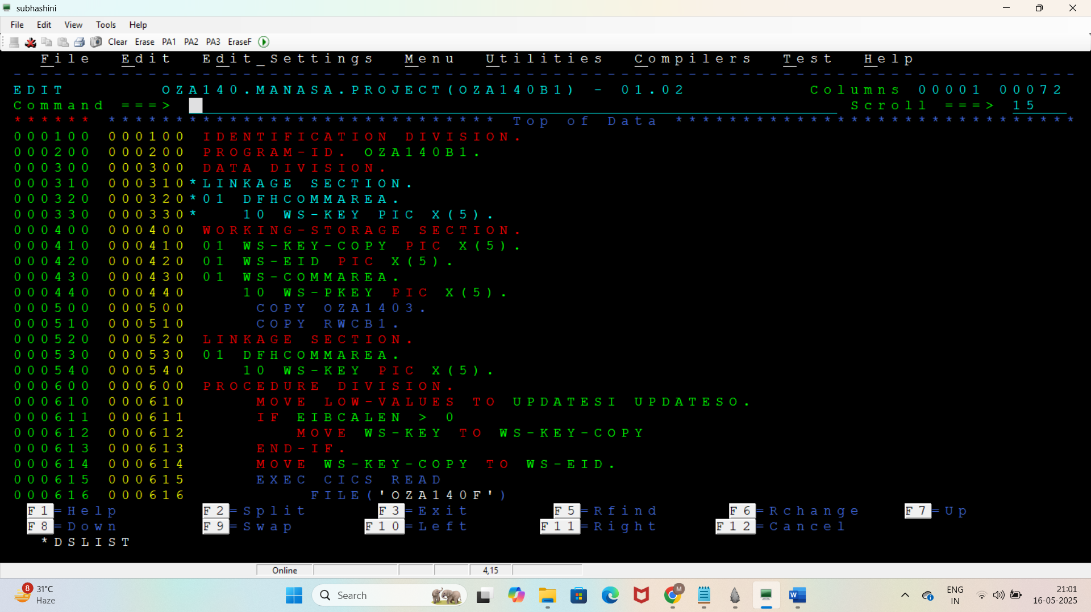

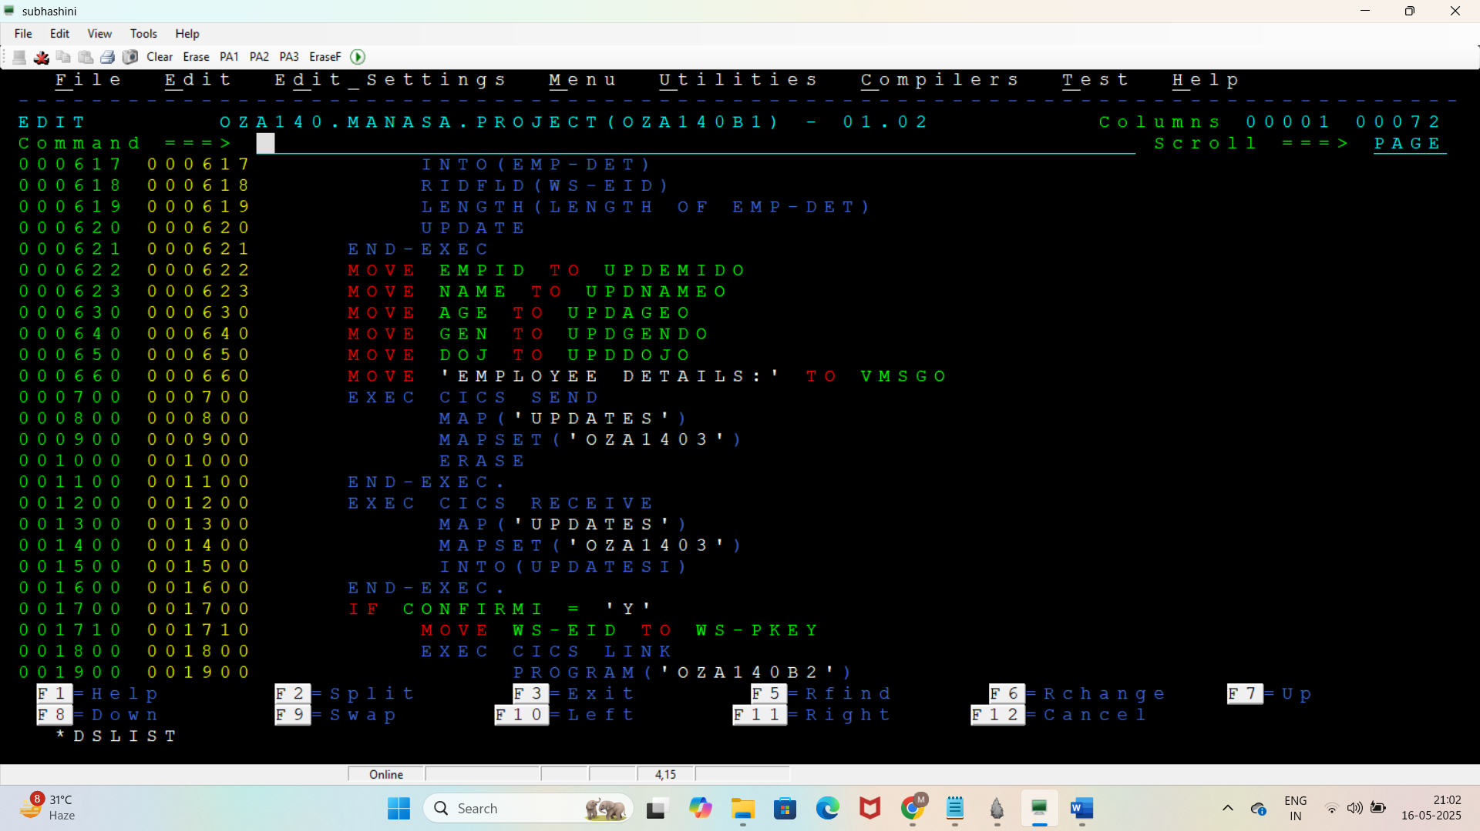

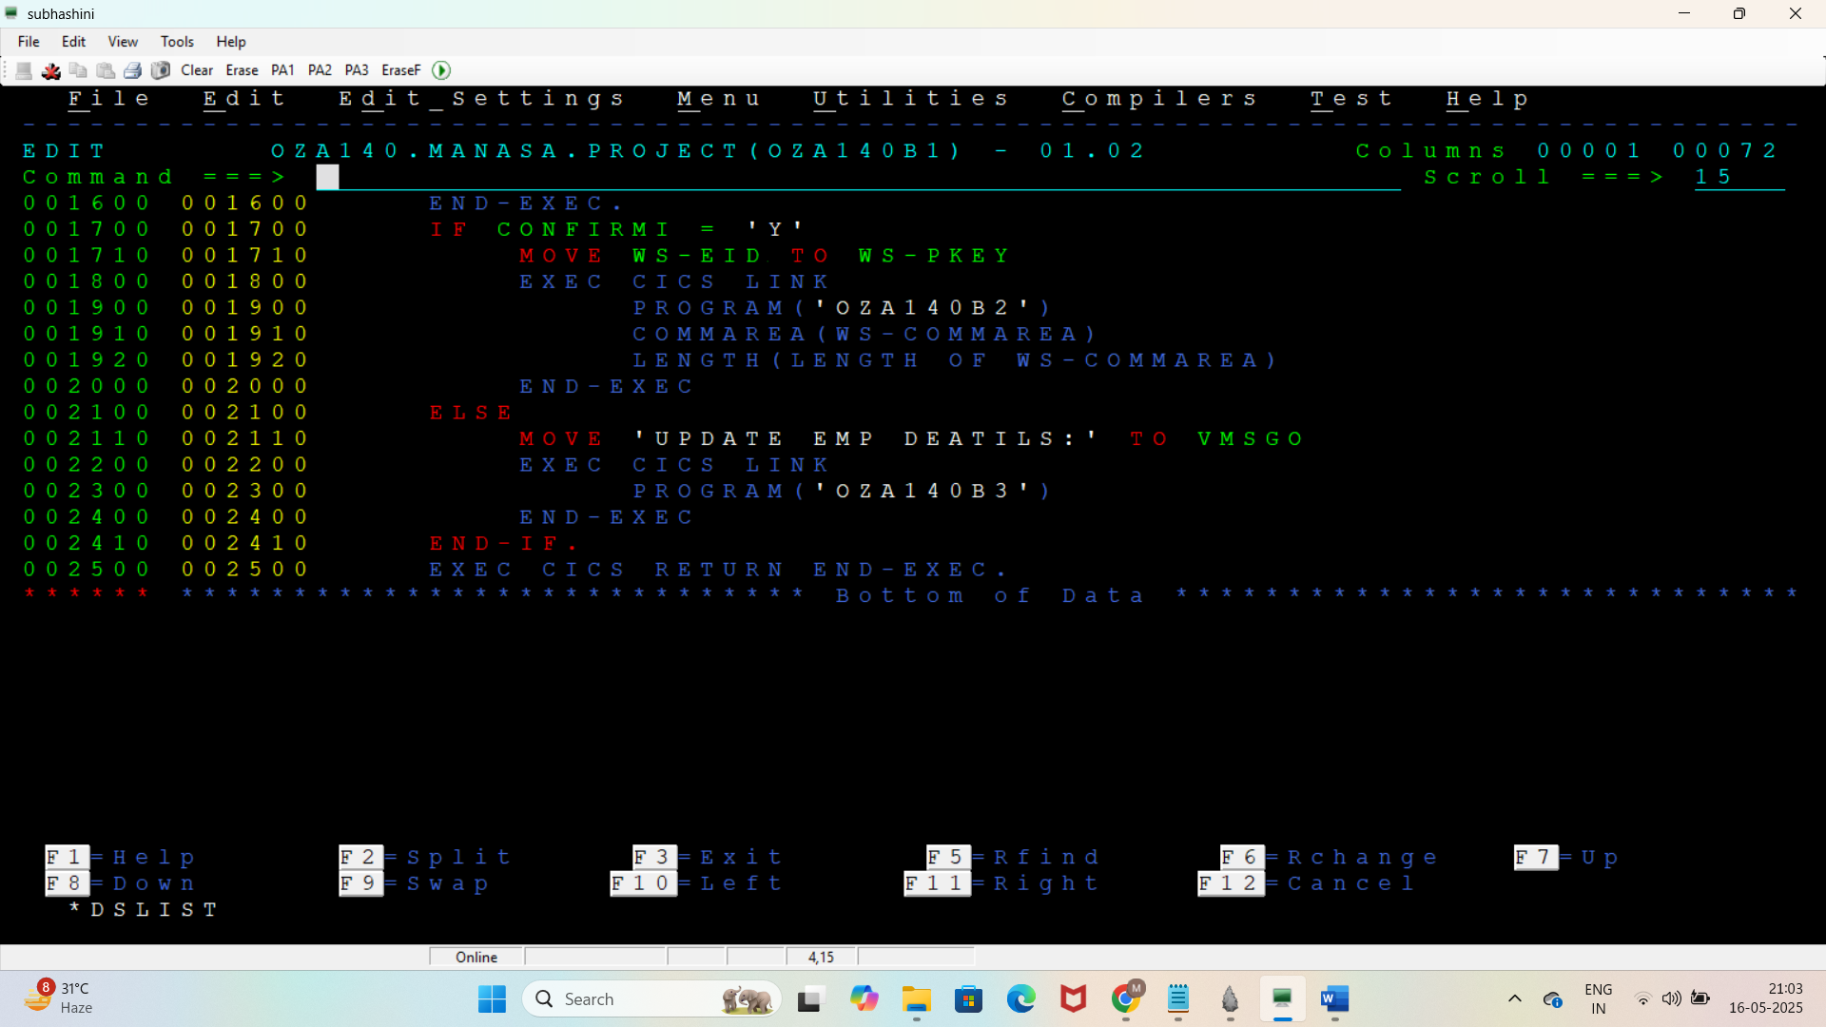

Subprogram2

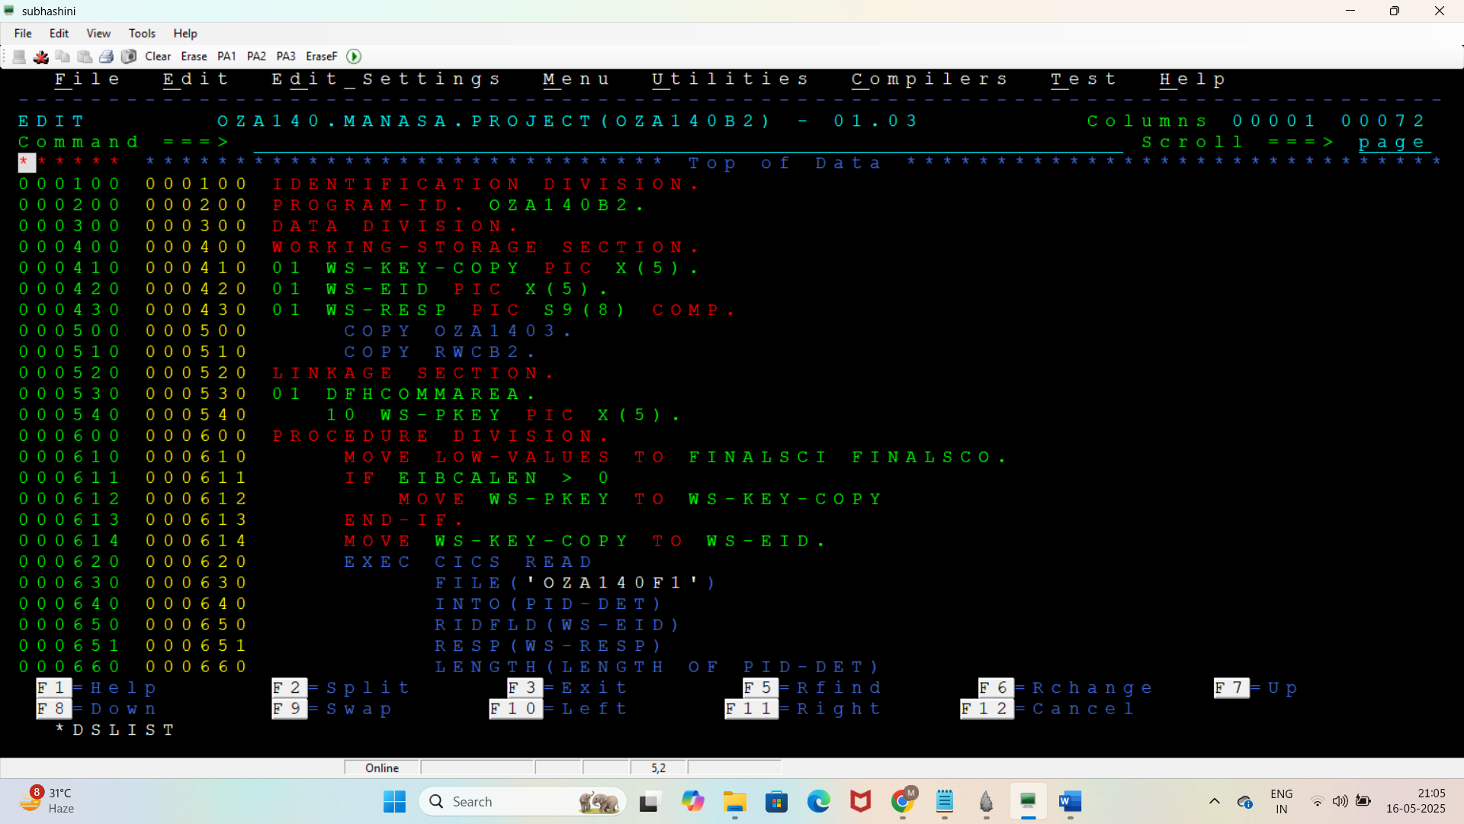

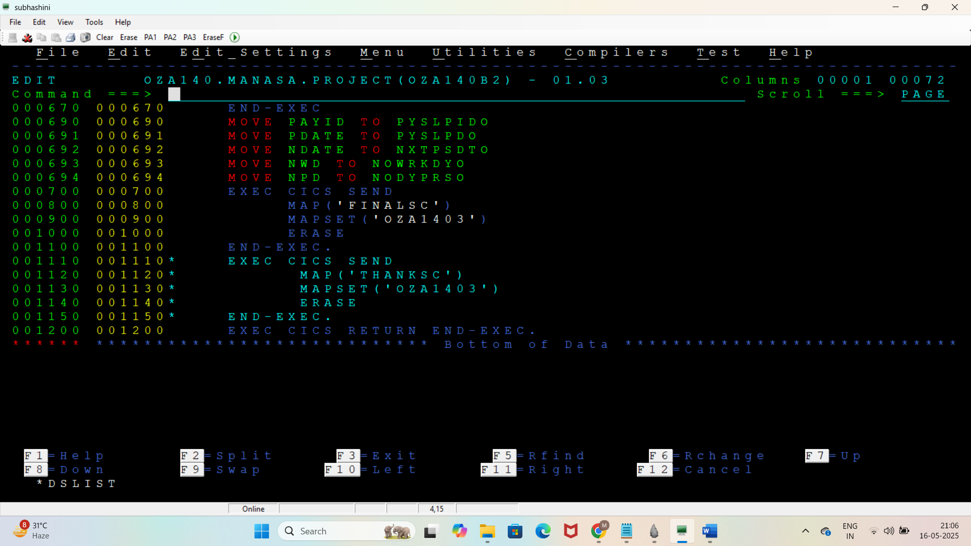

Subprogram3

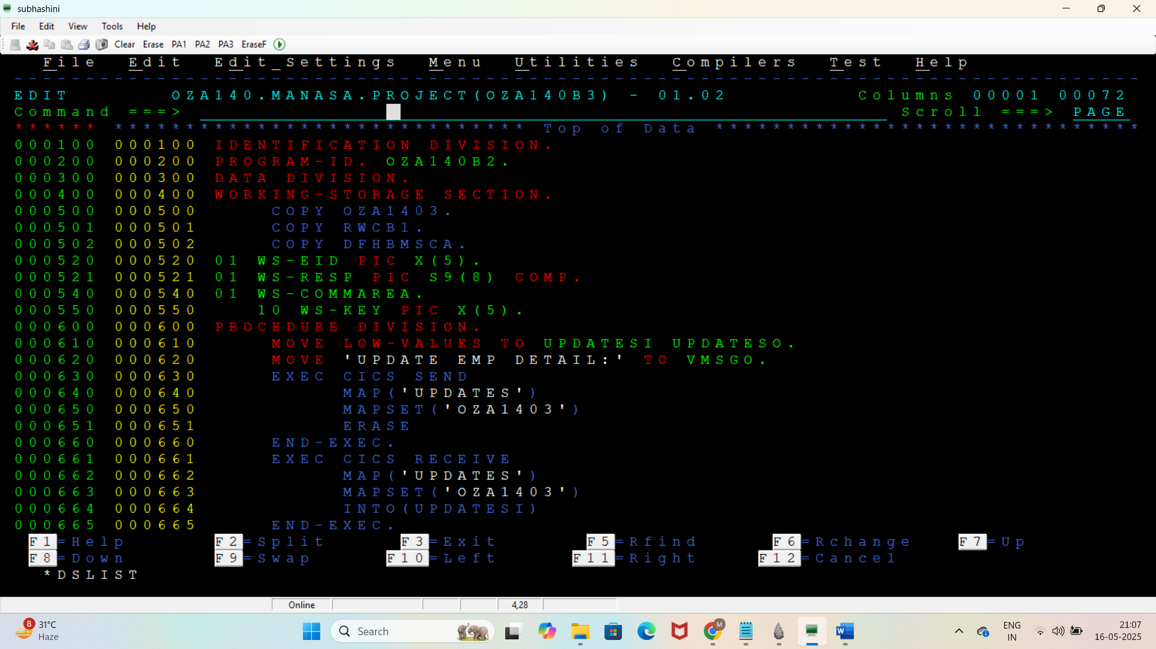

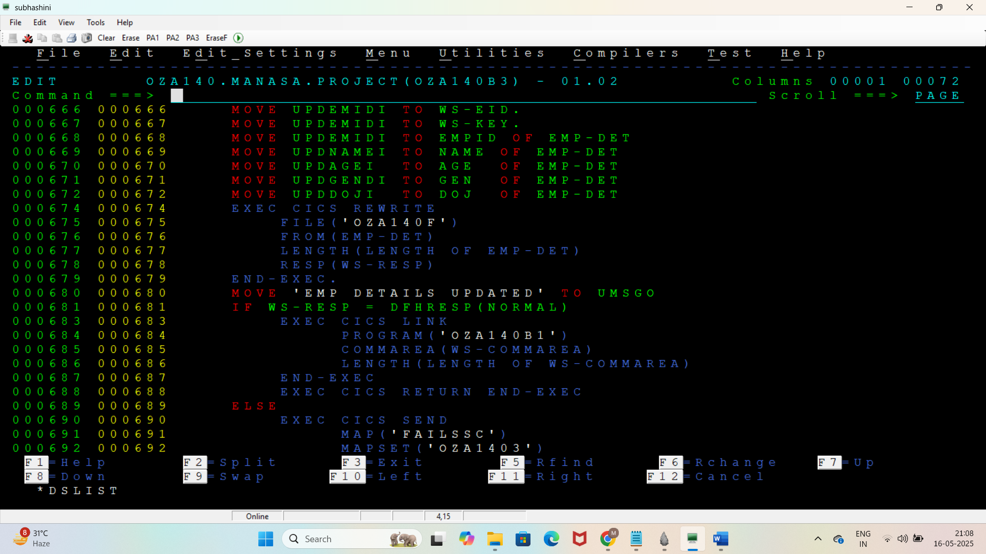

Subprogram4

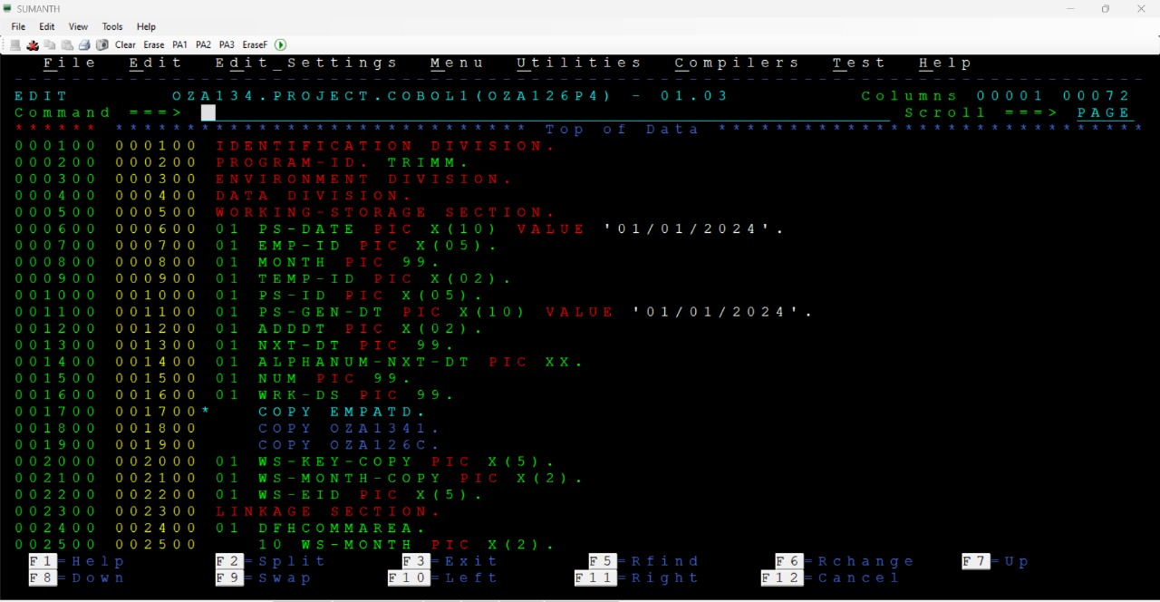

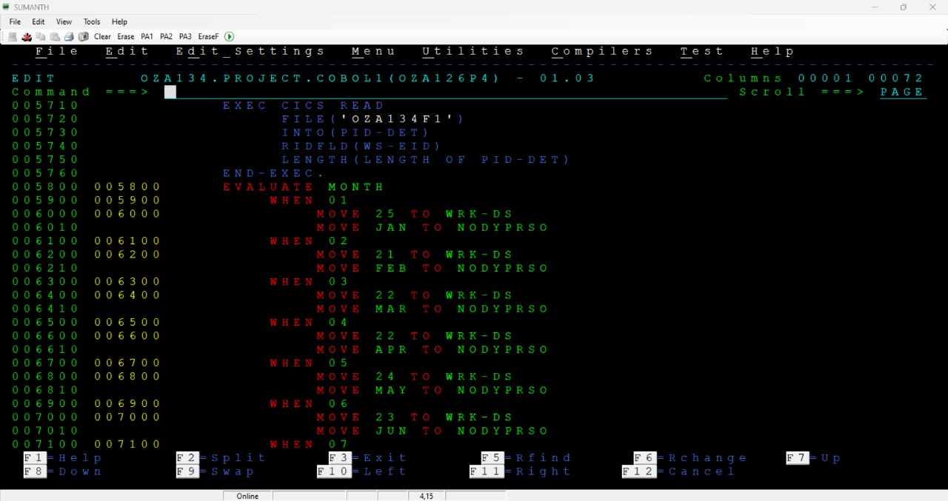

Subprogram5

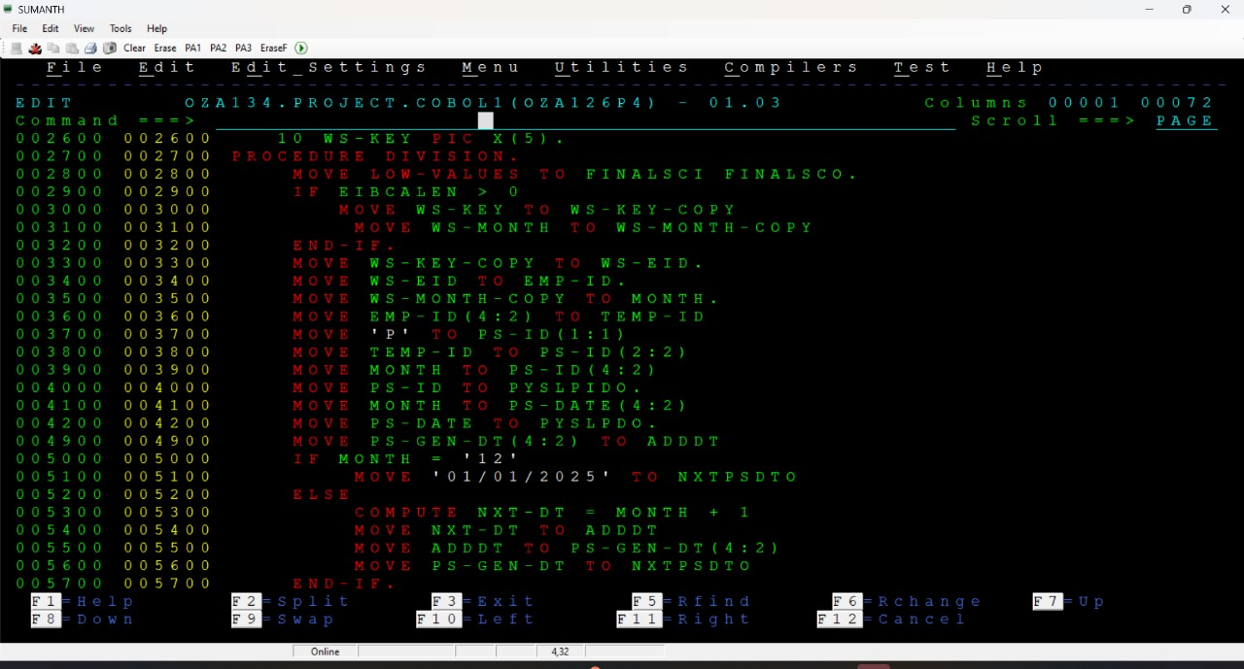

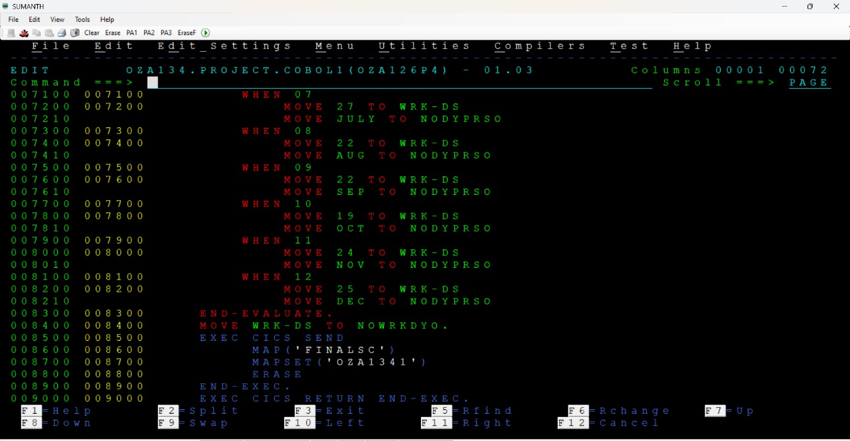

Assembler code for cobol

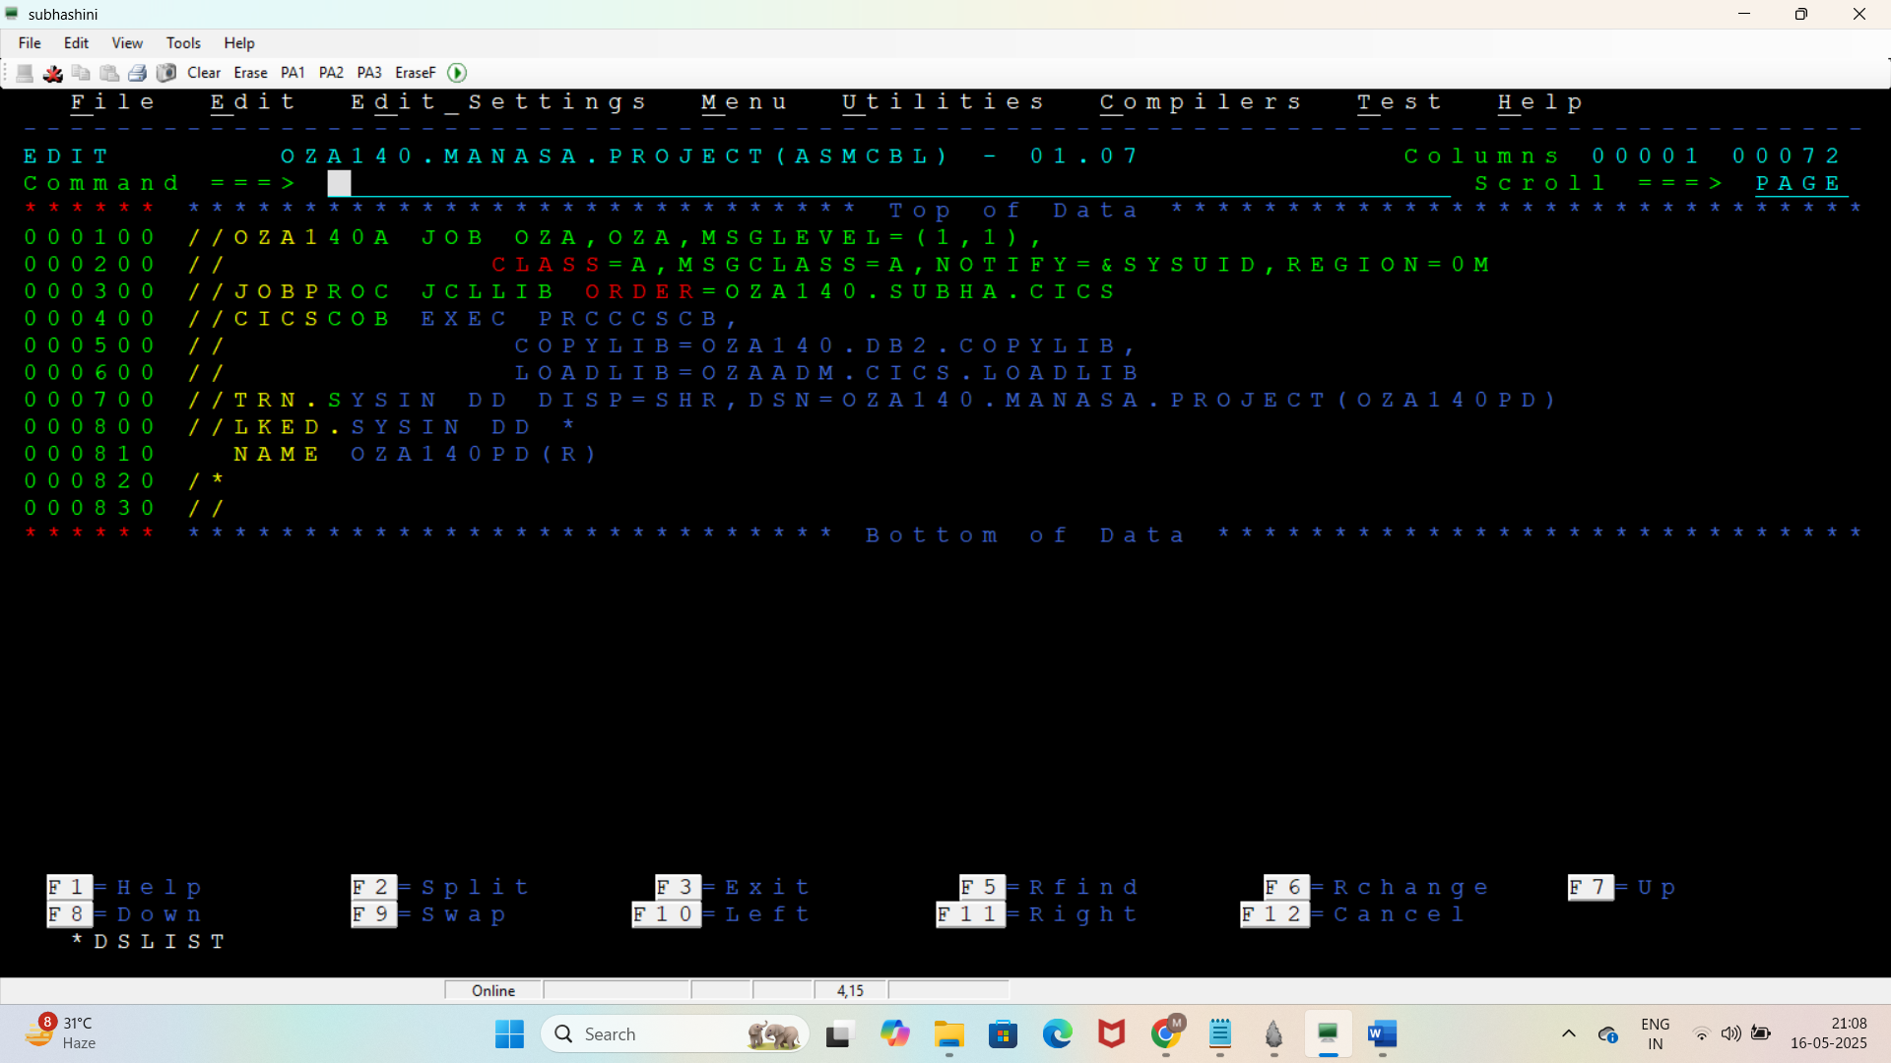

## **3.** **Working**

* 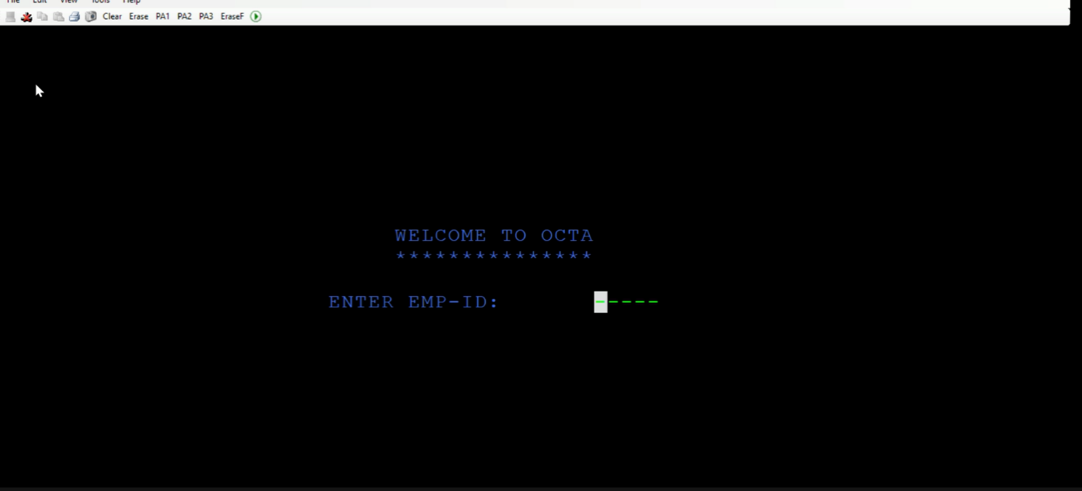If Employee ID is entered the system searches Employee ksds using keyed access
* If found, Corresponding Employee data will be displayed(name, age, gender, date of joining) else it display Login failed.

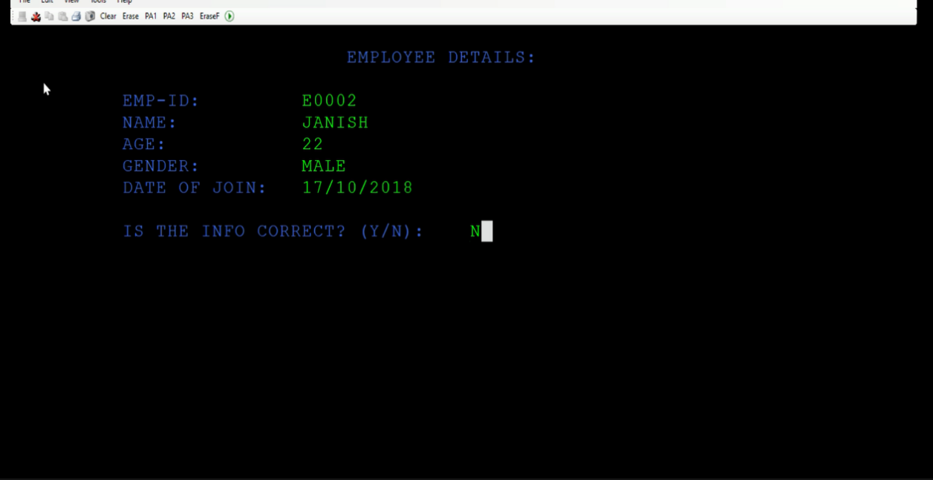

* If employee wants to update employee data, can switch to next screen editable fields are displayed for update.

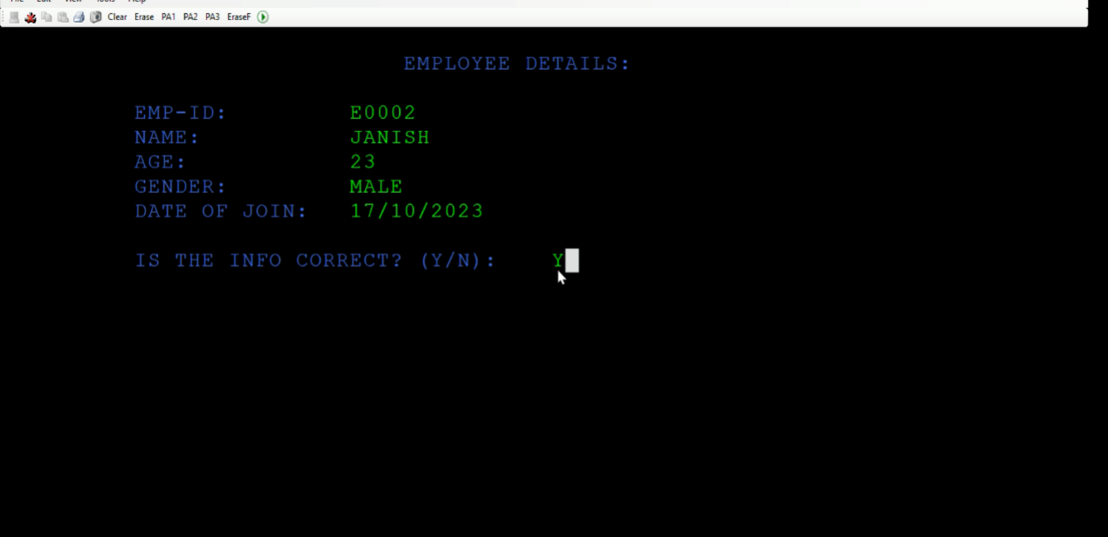

* If user wants to continue, can switch next screen that is payslip details (payslip-id, payslip-date, next payslip-date, number of working days).

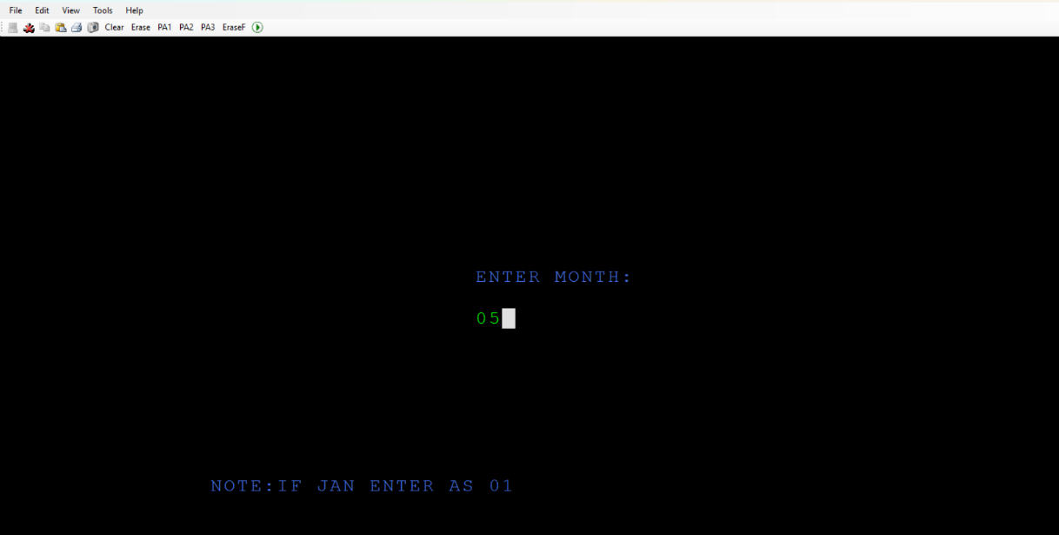

* Here, enter month as a numeric and click enter. In next screen it will generate the payslip id of particular month and other details.

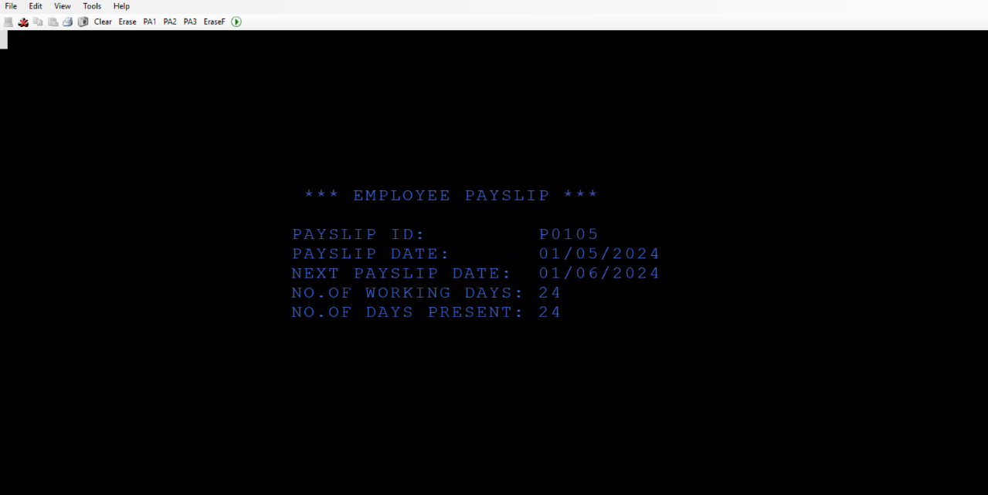

* It shows the payslip id, payslip-date, next payslip date, number of working days and number of presented days.

PROJECT TEAM MEMBERS

Vtu20262 B R. Sumanth

Vtmt14274 Dinesh S

Vtmt14220 Rakul V

Vtu19613 P.Neeraja

Vtu19394 A. Mounika

Vtu21098 S vl. Sai Neha

Vtu20427 S CV Subhashini

Vtu19491 V. Manasa